Proyek ISYS6596003
Sistem Informasi <<Starwave>>

Kelas : BL11
Kelompok : 2
Anggota :
DARREN NATHANIEL CHANDRA/ 2802571981
THIO MICHAEL YULIANTO/ 2802550781



BINUS UNIVERSITY
Jakarta Ganjil 2024/2025

1. Persona

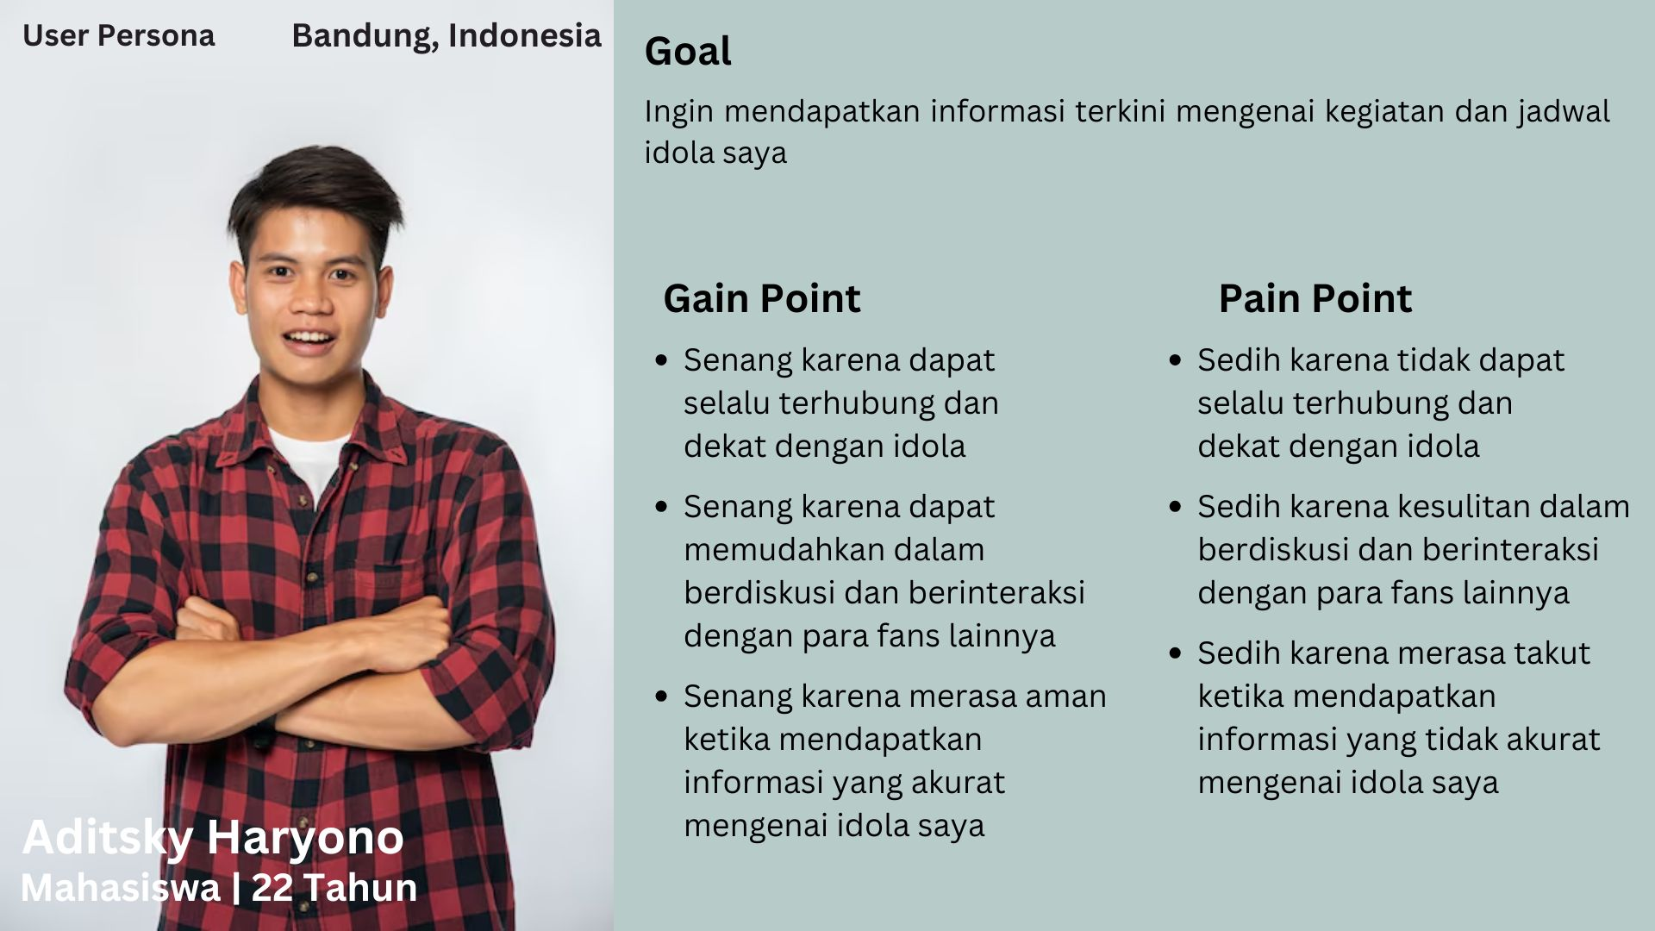

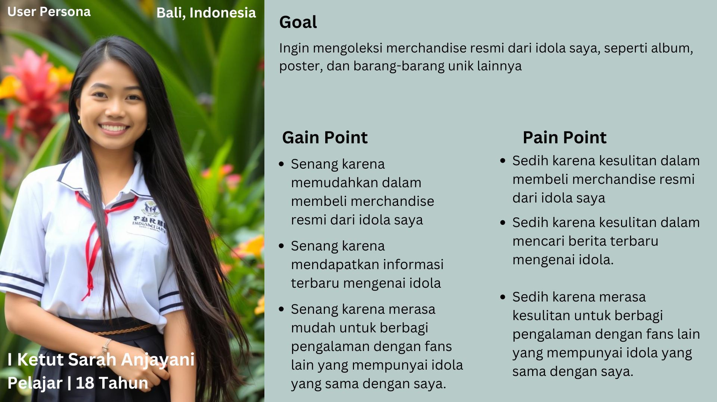

2. User Journey
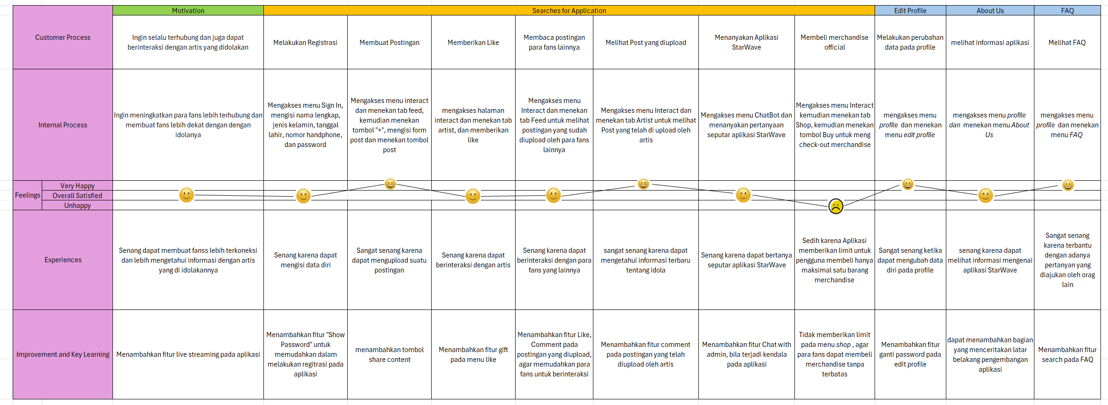

https://docs.google.com/spreadsheets/d/1s5ffKToP3hFsdueUCFjaHkirFmfgBtTa/edit?usp=drive_link&ouid=106000366178555106389&rtpof=true&sd=true

3. Task flow

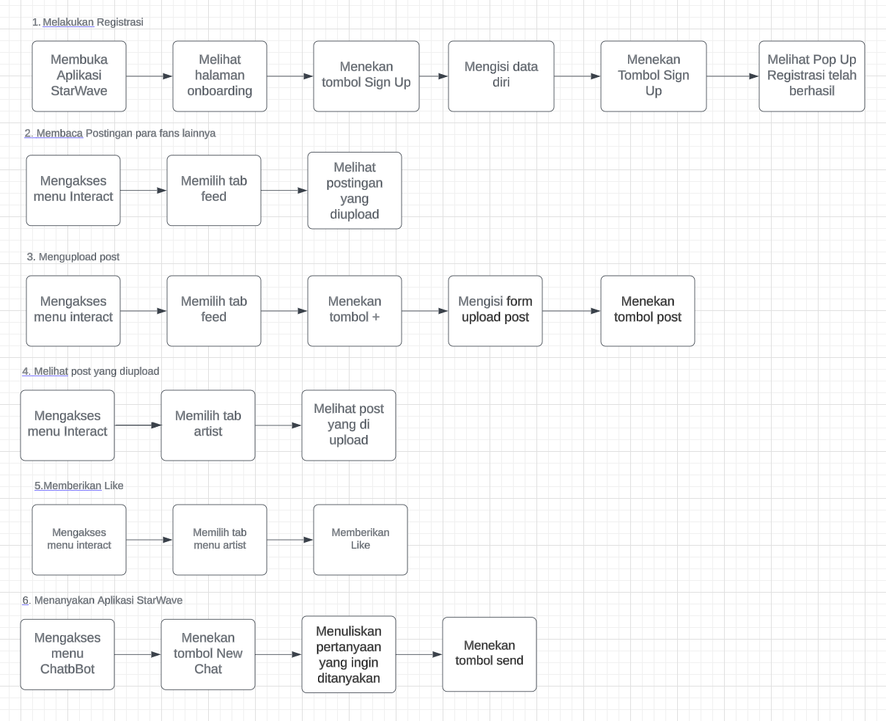
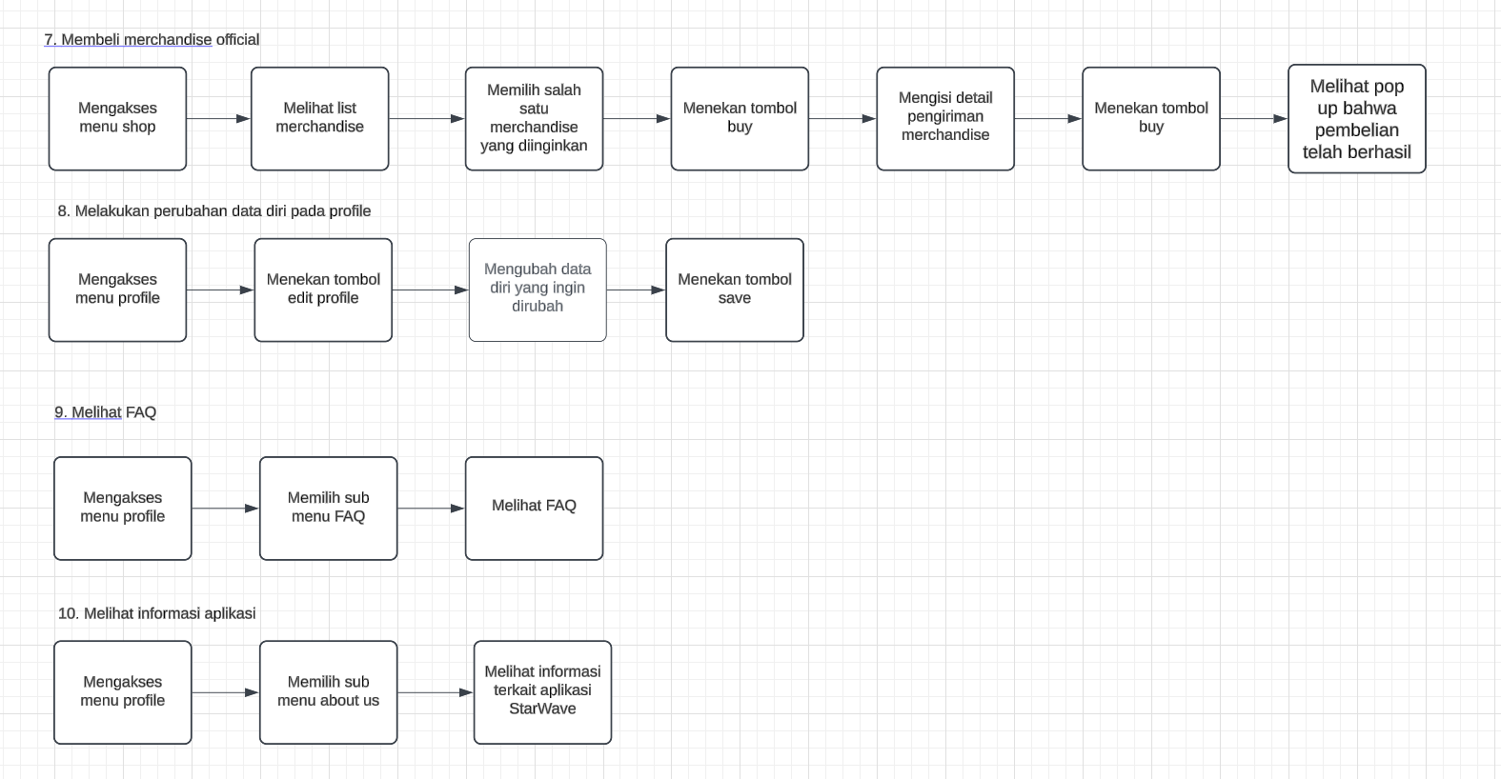
4. Wirefram Tanpa Garis

a. halaman splash screen
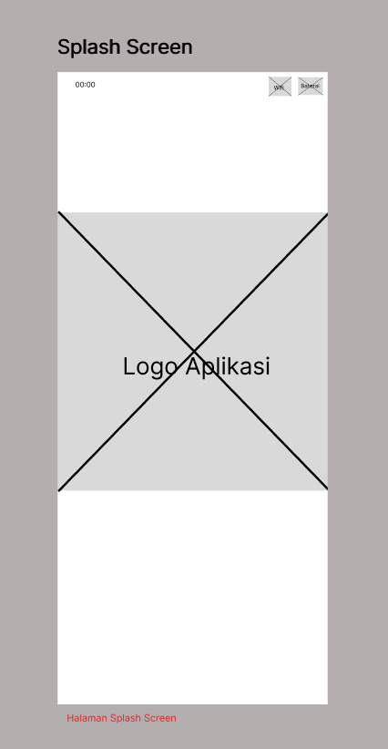
b. halaman onboarding
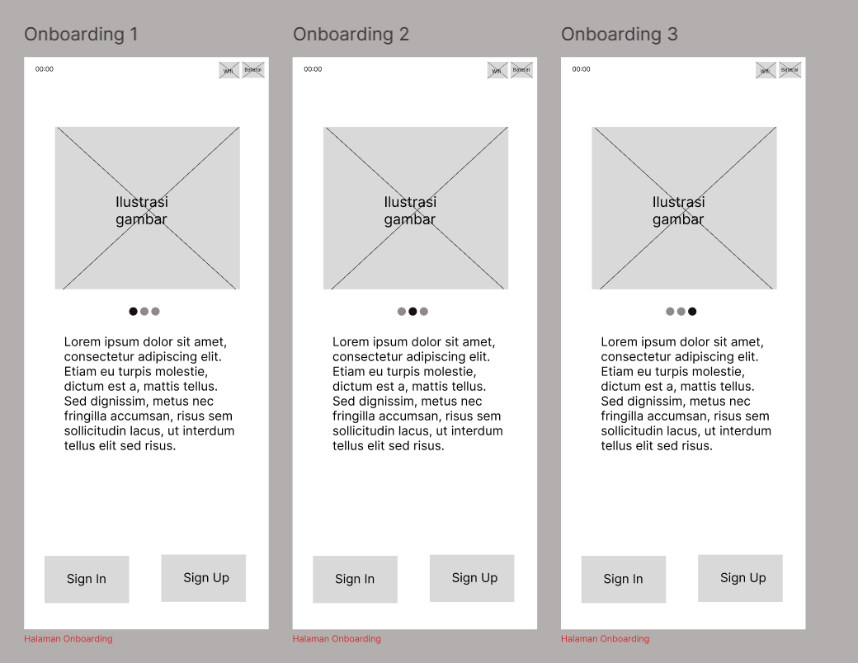

c. halaman sign in, pop up message, sign up, pop up message
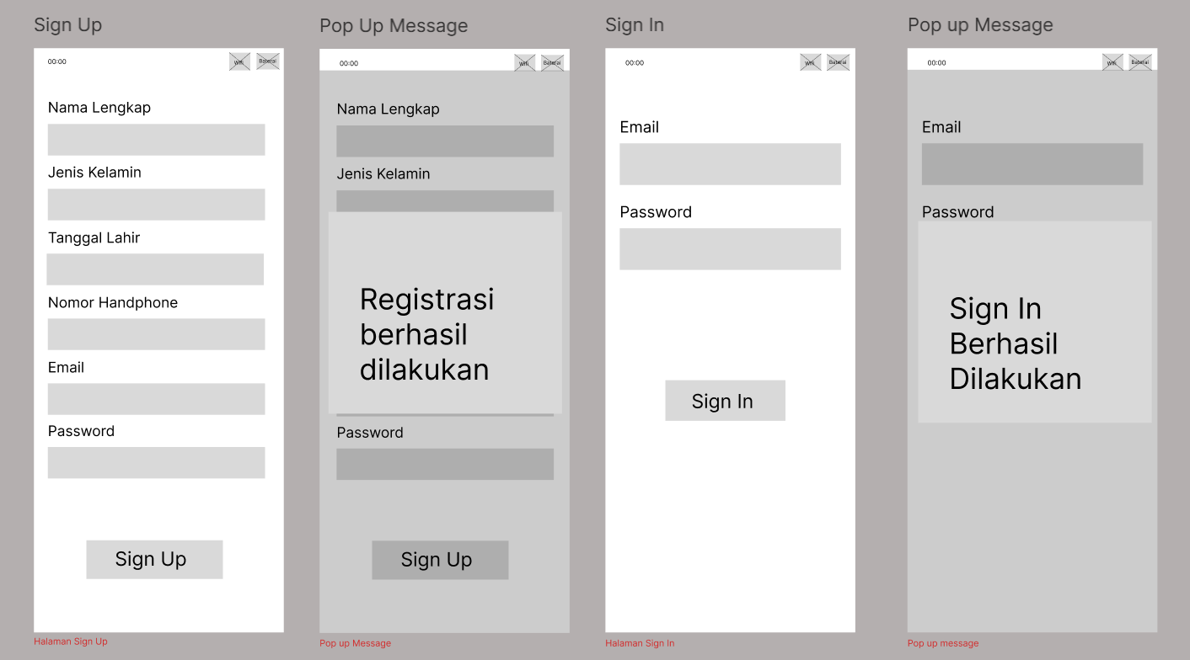

d. halaman home
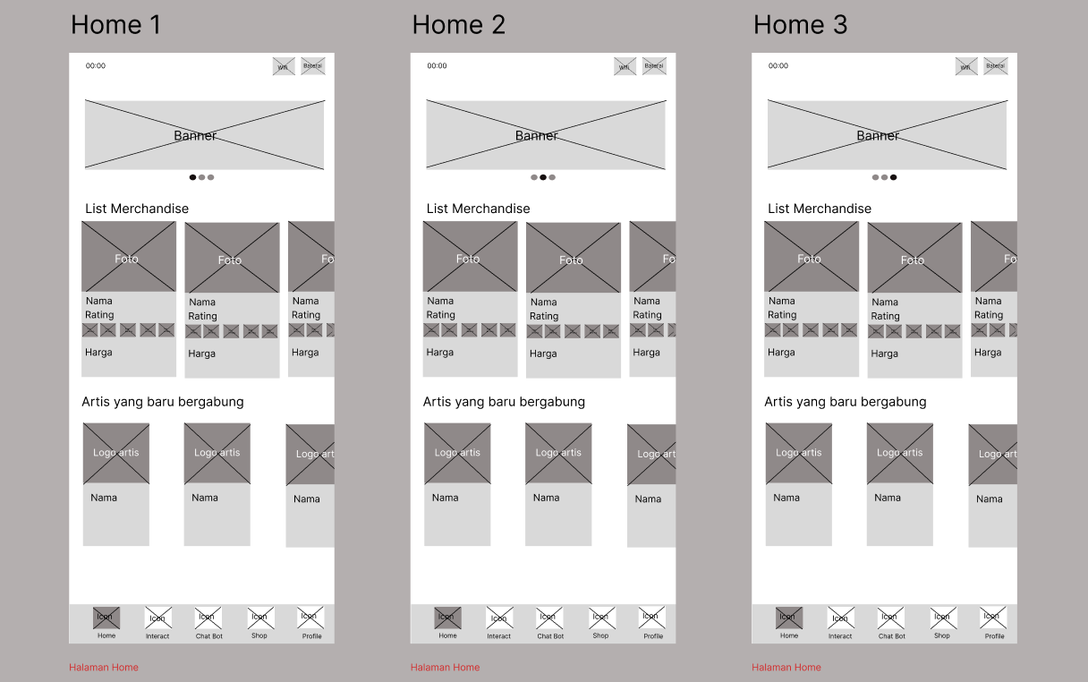

e. halaman interact, feed, upload post, artist
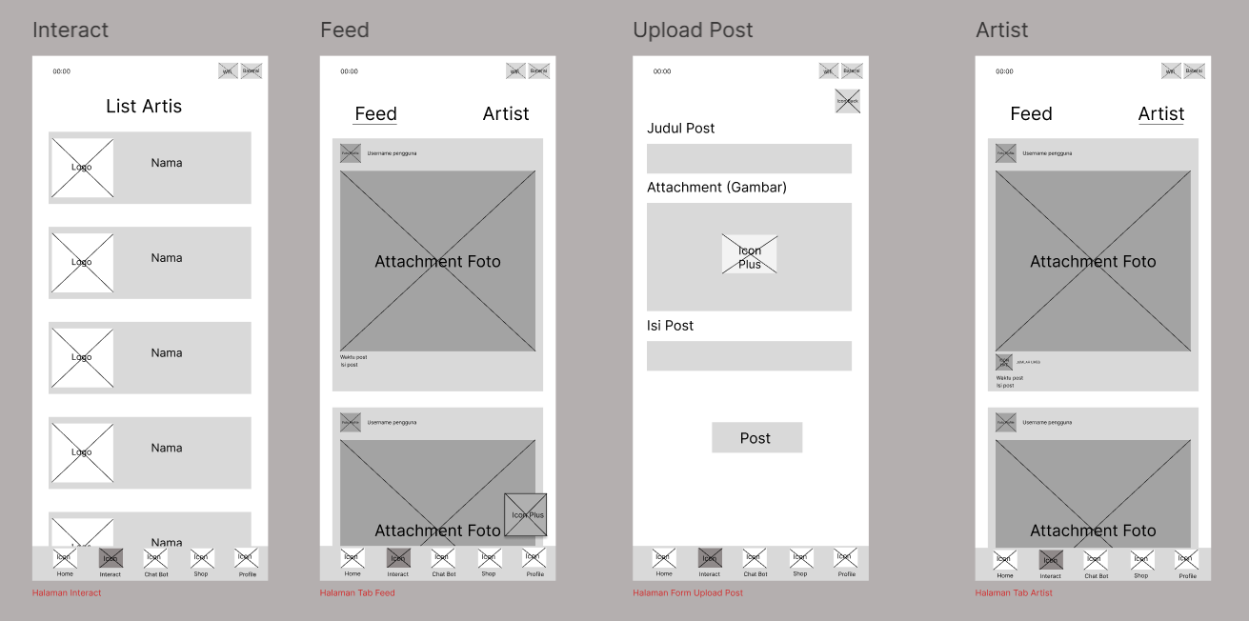

f. halaman chat bot, chat room
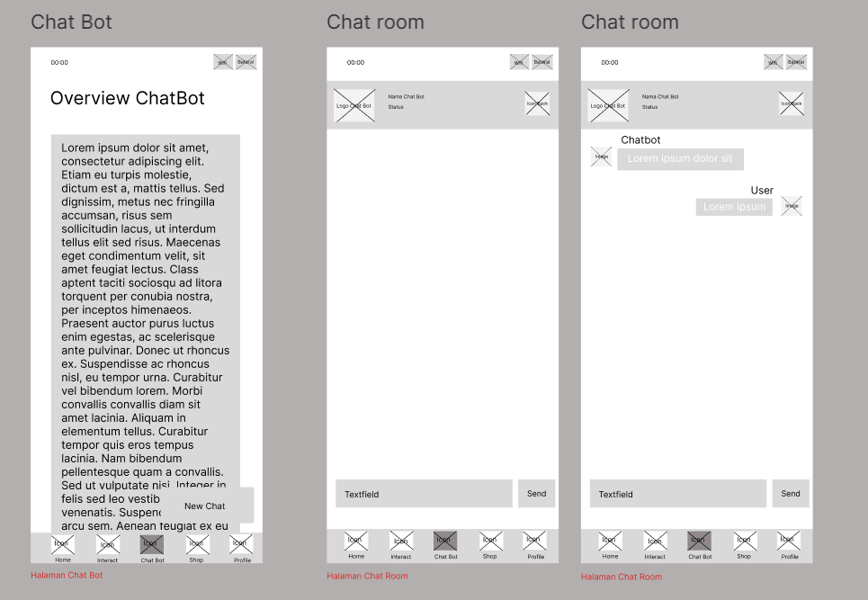

g. halaman shop, detail merchandise, check out, pop up message
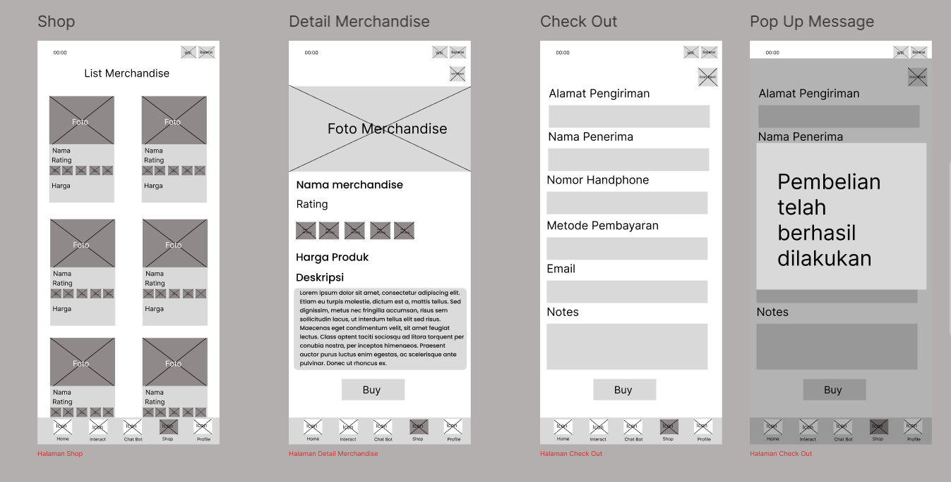

h. halaman profile, update profile
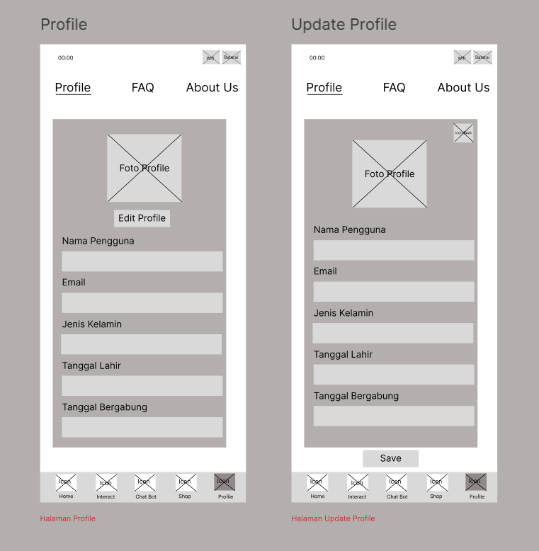

i. halaman FAQ
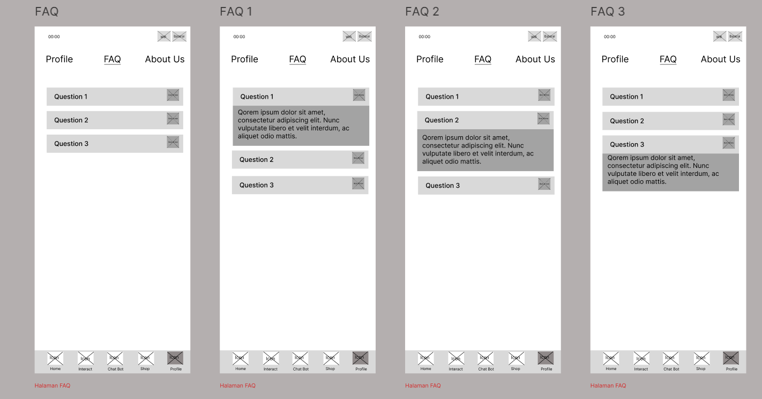

j. halaman about us
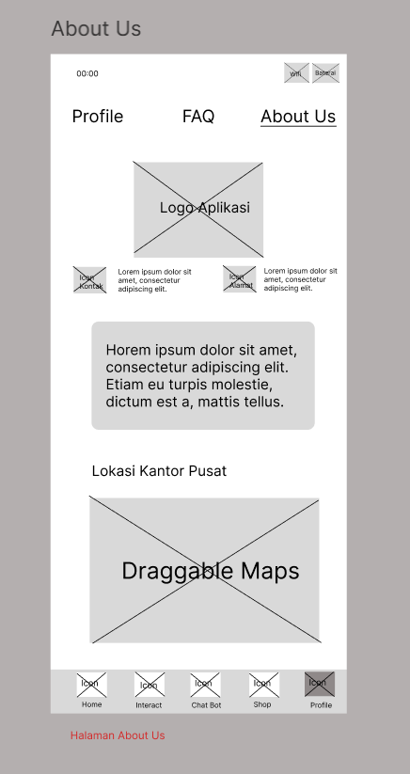

5. Wireframe dengan Garis
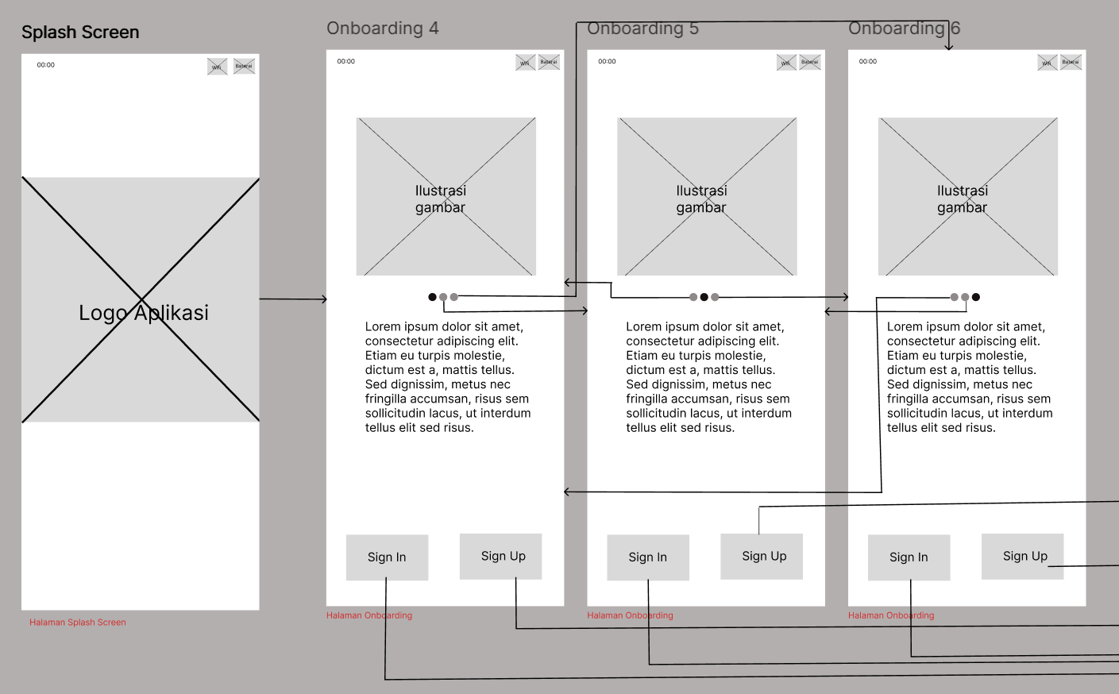
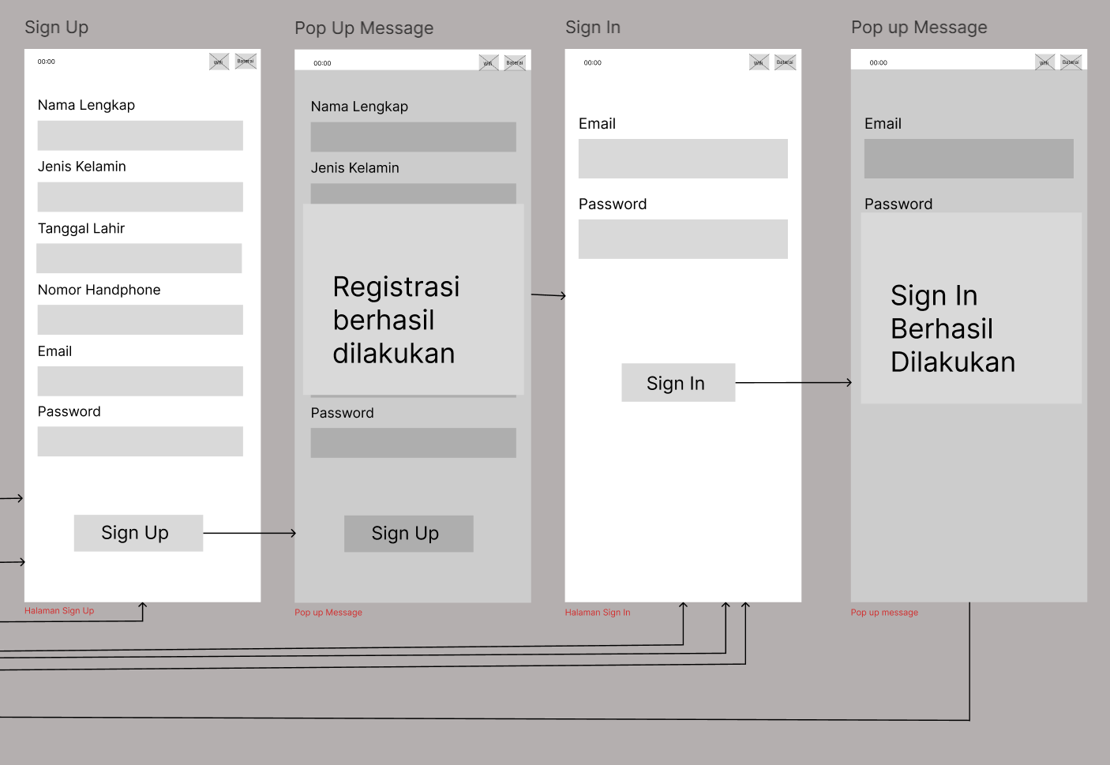

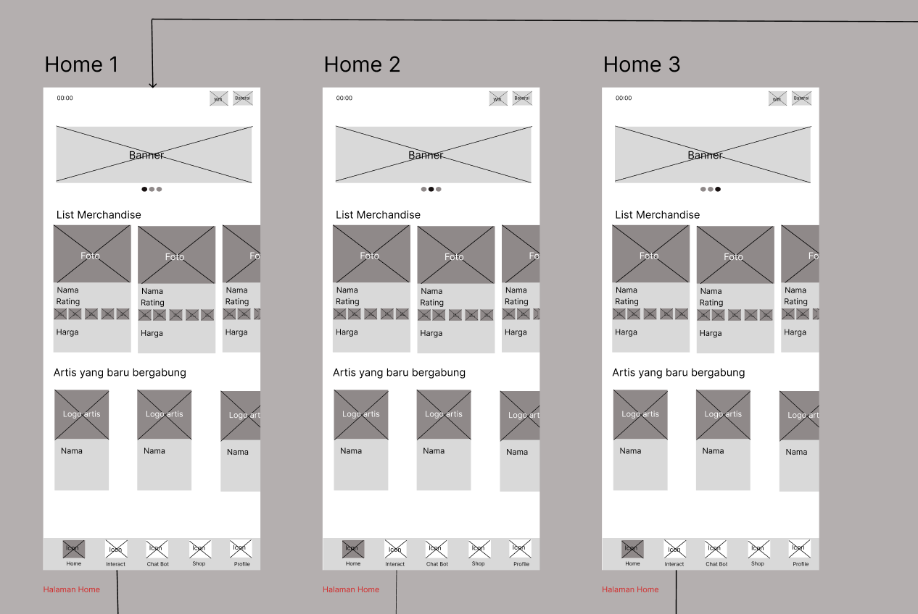

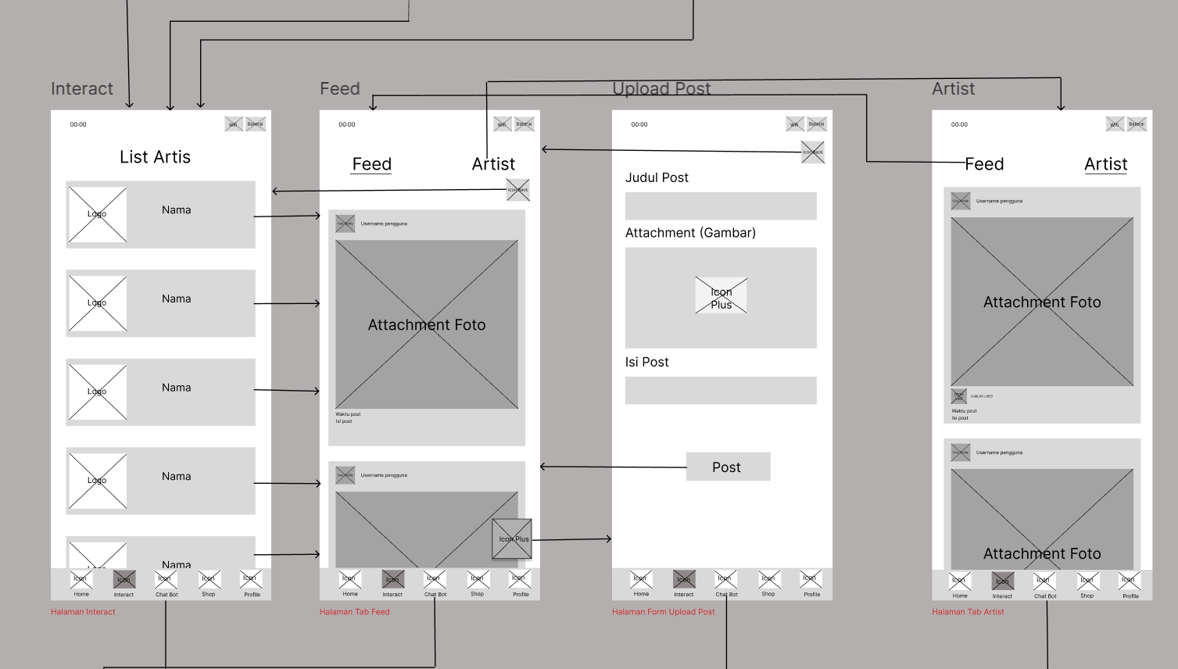

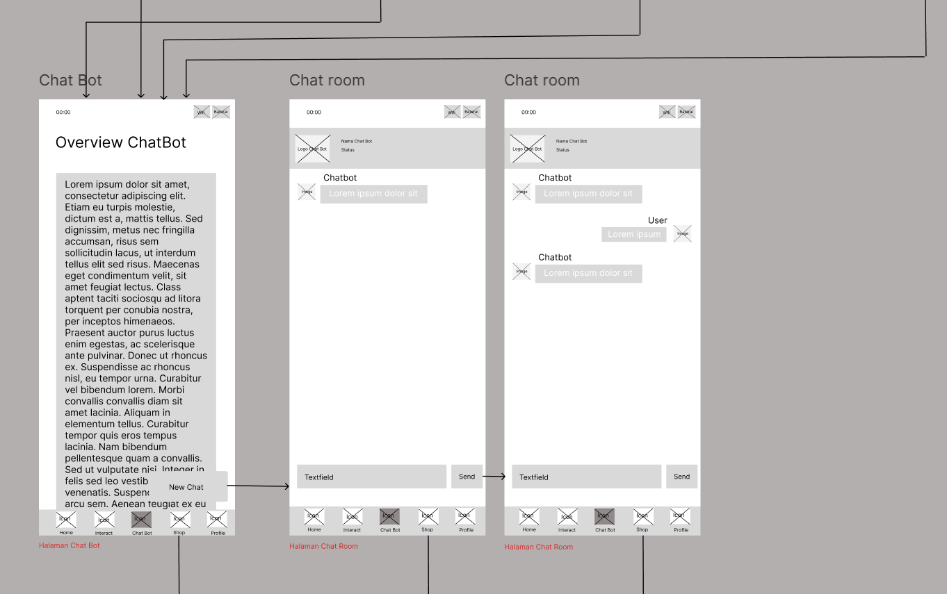

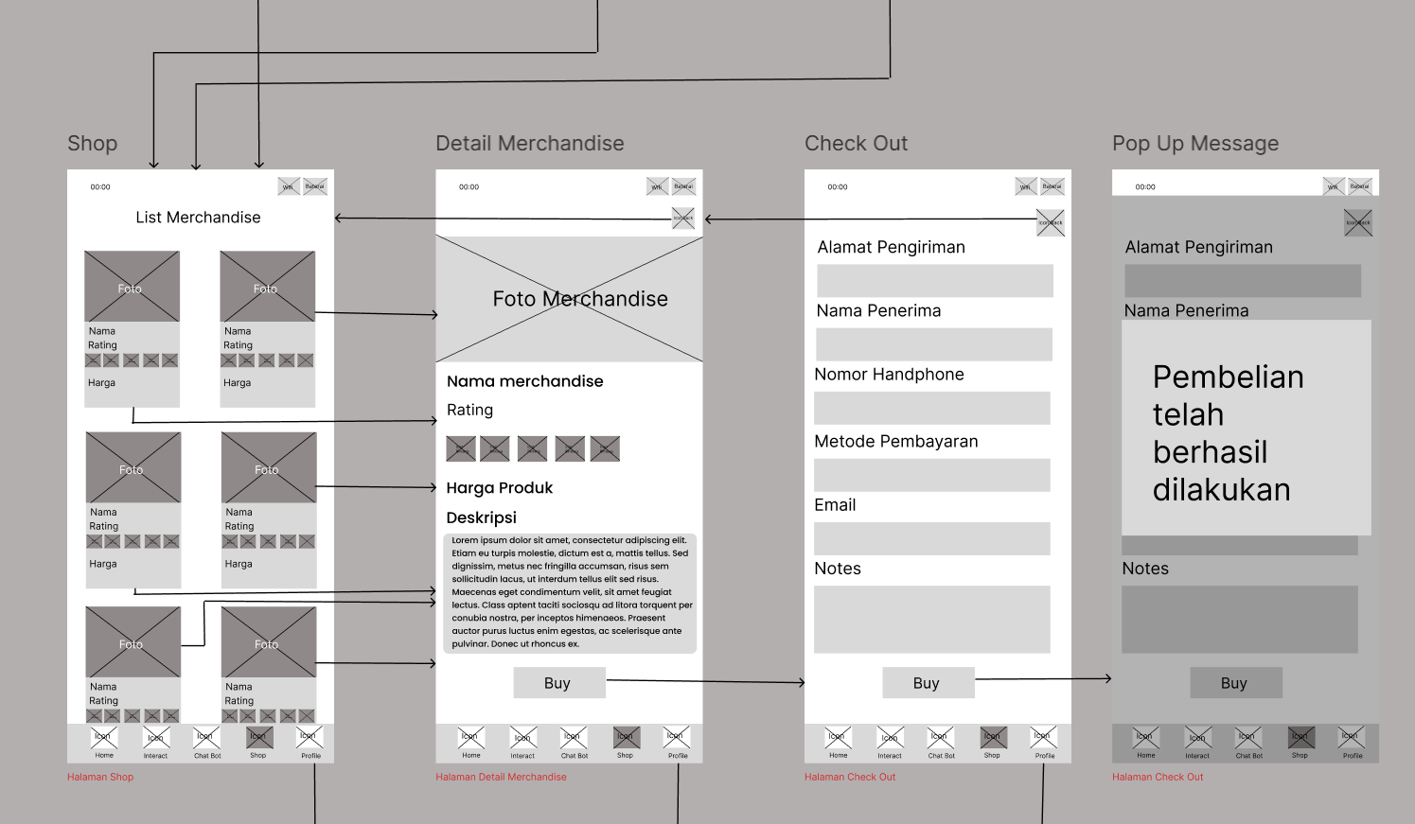

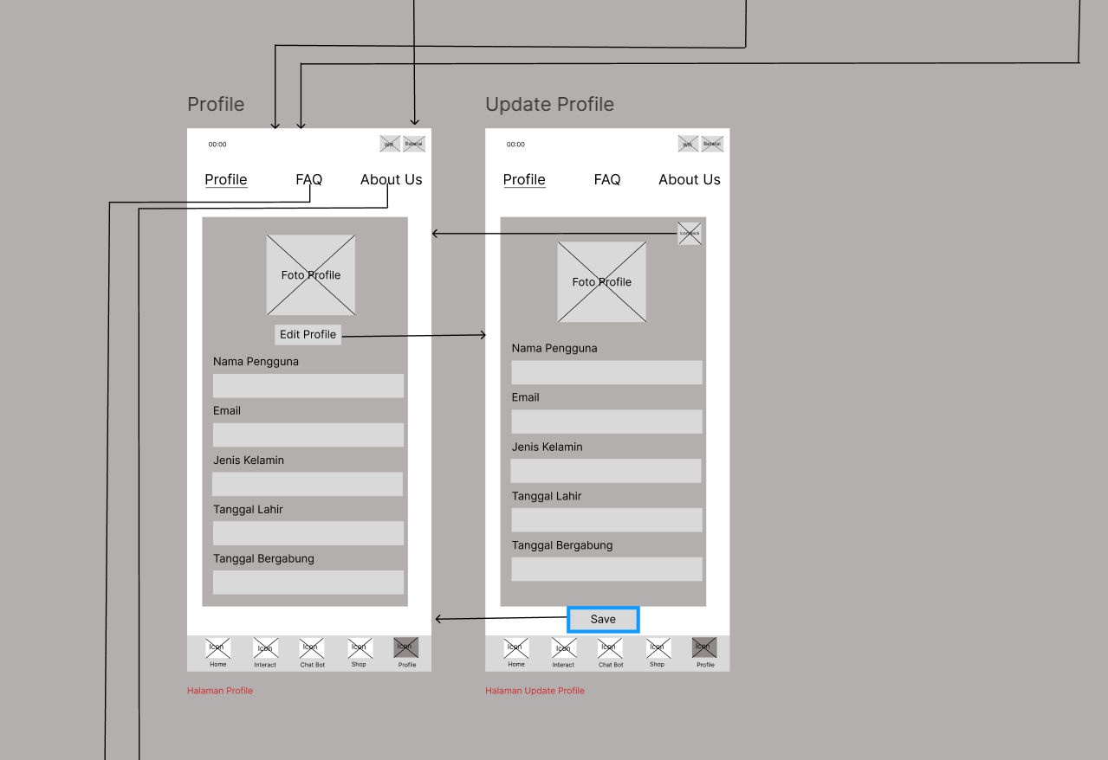

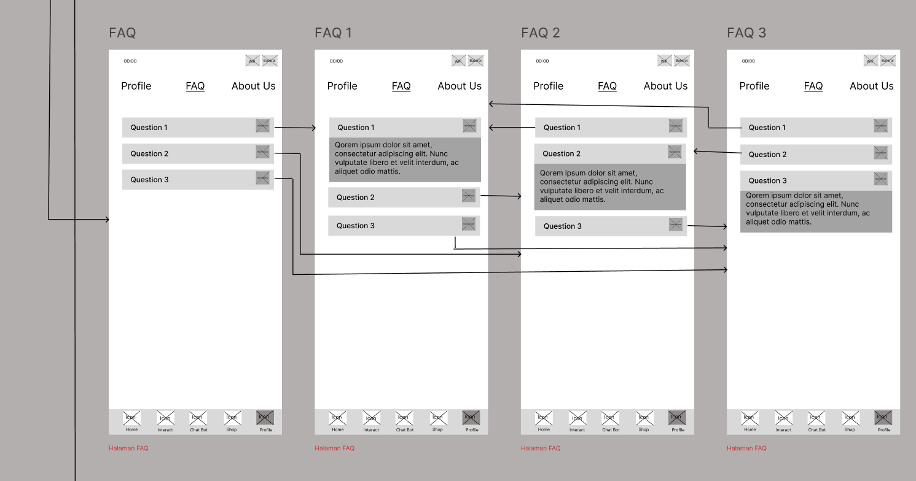

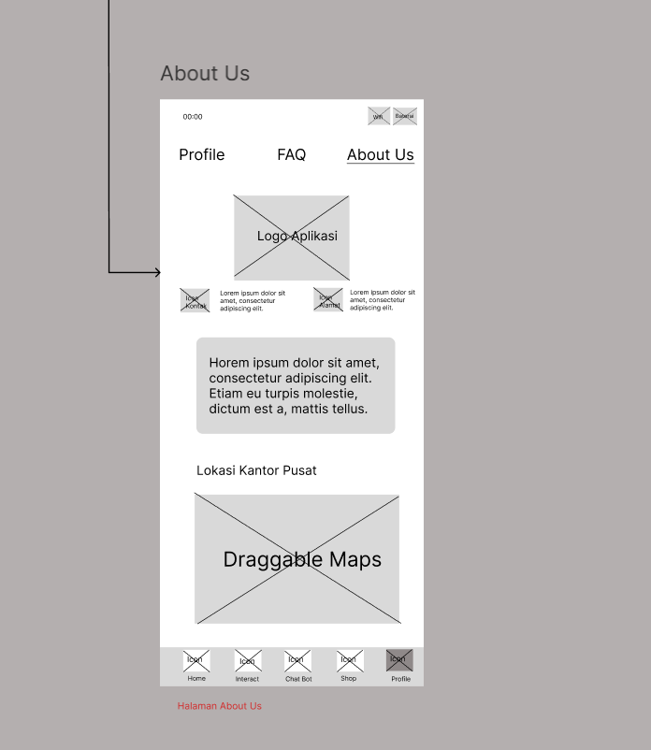

https://www.figma.com/design/4cNVZhn8ZvhibAv4TMnCqW/Wireframe---StarWave---2?node-id=0-1&t=Gtef8y300HosXd4R-1

6. Navigation Map

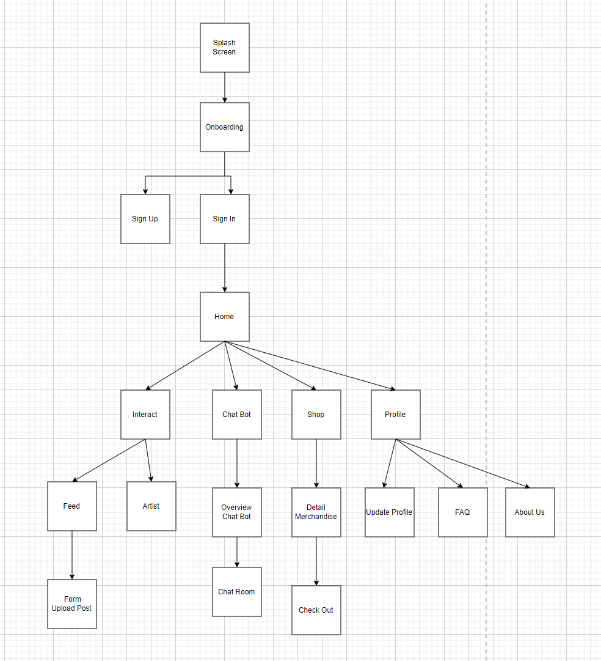

Referensi: Gambar yang kelompok kami ambil berasal dari pexels dan pixabay

